EzFare –Transport 4 You

Design Description

Version 1.0

Doc. No.:

Revision History

Date | Version | Description | Author
2010-10-04 | 0.01 | Initial Draft | Kaushik Mohanraj, Shamsul
2010-11-20 | 1.0 | Diagrams with more details incorporated. | Kaushik Mohanraj
2011-01-17 | 1.2 | Detail of diagram | Faiz UL Muram

Table of Contents
1. Introduction 5
1.1 Purpose of this document 5
1.2 Intended Audience 5
1.3 Scope 5
1.4 Definitions and acronyms 5
1.4.1 Definitions 5
1.4.2 Acronyms and abbreviations 5
1.5 References 6
2. External interfaces 6
2.1 Vehicle Unit 6
2.2 Transport Manager 6
2.3 Web Application 6
2.4 Mobile Unit 6
2.5 Mainframe 6
3. Software architecture 7
3.1 Conceptual design 7
3.2 System specification 8
3.3 Error handling 8
4. Detailed software design 9
4.1 Database Design: 9
4.2 System Architecture 10
5. Approvals 11

Introduction

In today world Transport is the most essential part of any metropolitan management authority. Public Transport constitutes to major part of Transportation development for any administrative body. Thus in an effort to make Transportation/Commuting smoother for their consumers, an innovative ticketing procedure is been introduced.
This project aims in making the ticketing process user friendly and hassle free for the customers. The project incorporates features such as Ticket issuance just by click button and notifications if you are a regular traveller, and so on and so forth. Hence, the name of the project is now ‘EzFare’.

Purpose of this document
The purpose of this document is to provide an insight into the EzFare (Transport4you) project design, to describe the project's architecture and to give a broad prospective of the design of the entire system.

Intended Audience
The Intended Audiences of this document are:-
- The Team members to use as a reference during the Implementation phase of the project.
- The customer so as to understand the project scope.
- Team supervisor to have an overview of the project work.

Scope
The document serves to provide an understanding of overall system flow and overview of the design of the system and its intended functioning. The reader referring to the document will have a complete understanding of the system.

Definitions and acronyms

Definitions

Keyword | Definitions
VU | Vehicle Unit
MU | Mobile Unit
MF | Mainframe
TM | Transaction Manager
WA | Web Application
MC | Model Controller
DM | Domain Model

Acronyms and abbreviations

Acronym or  Abbreviation | Definitions
GPS | Global Positioning System
GPRS | General Packet Radio Service
Wi-Fi | Wireless- Fidelity

References
- Project Homepage:
  - http://www.fer.hr/rasip/dsd/projects/transport4you2
- Project Proposal:
  - http://score-contest.org/2011/Projects.php#dinitto

External interfaces

Vehicle Unit
The Vehicle Unit is the main interface between the Mobile Unit and the Mainframe. The VU will be Bluetooth and Wi-Fi enabled to communicate with the MU. At the same time it will be enabled to communicate with the MF with the aid of the Transport Manager. The data that will be sent using the TM will be in the format that would be easily interpreted by the MF to log data relevant information into the database.

Transport Manager
The Transport manger is aimed to aid communication between the VU and the MF. The TM is makes communication possible using the WCF REST services.

Web Application
The Web application provides the users of the system an interface to interact with the system. The system is intended to be used by users of two types, the Passengers (Frontend) and the administrators (backend) of the system. Hence a logical division of the web application was done as mentioned.
Frontend: The passengers will be using this WA to provide details pertaining to the individual and other relevant details regarding the MU that would be used by the passenger and to fill in details to by credits to be used for travelling.
Backend: The system administrators are provided with an interface to monitor the system and to make changes related to the system such as search passenger, delete passenger, send SMS to passengers of one line and inclusion of new routes or editing of existing routes.

Mobile Unit
The Mobile Unit is the application that has been developed (restricted to Android OS) and is at the disposal of the passenger for interacting with the system when on the move. This application helps the passenger to connect to the system and perform transaction.

Mainframe
The mainframe is the Think-Tank of the system that performs all the logical operations, handles and manipulates the data that flows within the system. Hence being the brain of the system all communication happens through the Mainframe at some point of time.

Software architecture

Conceptual design
To provide a vivid prospect of the design of the system and its workflow we have taken the aid of a Sequence Diagram.
Here the following figure will give you a broad view of the events that occur in the system.

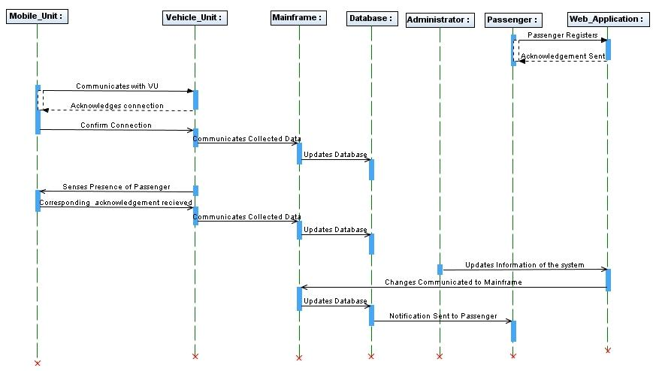
Figure 1

System specification

The Project would be developed by means of varied Programing Languages. As there are various different independent applications that would be communicating with each other using various protocol that have been listed out in the table below:

Element | Description | Intend of using it
Web Application | Visual Studio .NET 2010 | The WA to be used by Admin and Customer
Mobile Application | Java
Mobile Unit |  | This element will be used to detect the Passengers in the vehicle and communicate with the MF.
Vehicle Unit |  | Provide an interface for communication between the MU and MF
GPS |  | To determine the positioning of the vehicle
GPRS |  | To make possible the communication between the MF and the VU
Bluetooth/ Wi-Fi |  | To establish communication between the MU and the VU

Error handling

Error | Action
Detection of user even if not on board | Perform continues checks when the vehicle is in motion and ensure only the users on board are charged for their trip.
VU Crash | In this scenario the VU will restart and initiate the process, and will not continue from where it crashed. Data inconsistency will not occur, as when the data received by the MF is not in the correct format or incomplete it just discards the data and will not send an acknowledgement to which the VU will resend the same information.
Hardware Failure  (Bluetooth or Wireless Adapter) | These Failures cannot be handled programmatically.

Detailed software design

Database Design:

Object relation mapper is used for solving the persistence problems and is handled by using NHibernate. As a result of using NHibernate, modifications and testing is easily performed on domain. Microsoft SQL Server 2008 is used as a database but establishing a connection by using connection string is required for configuration with specified system. We write Xml mapping for each entity of domain. Mapping files contain information for mapping, for example, classes and their relationships with each other in the database. Database design is presented in figure 2 below:

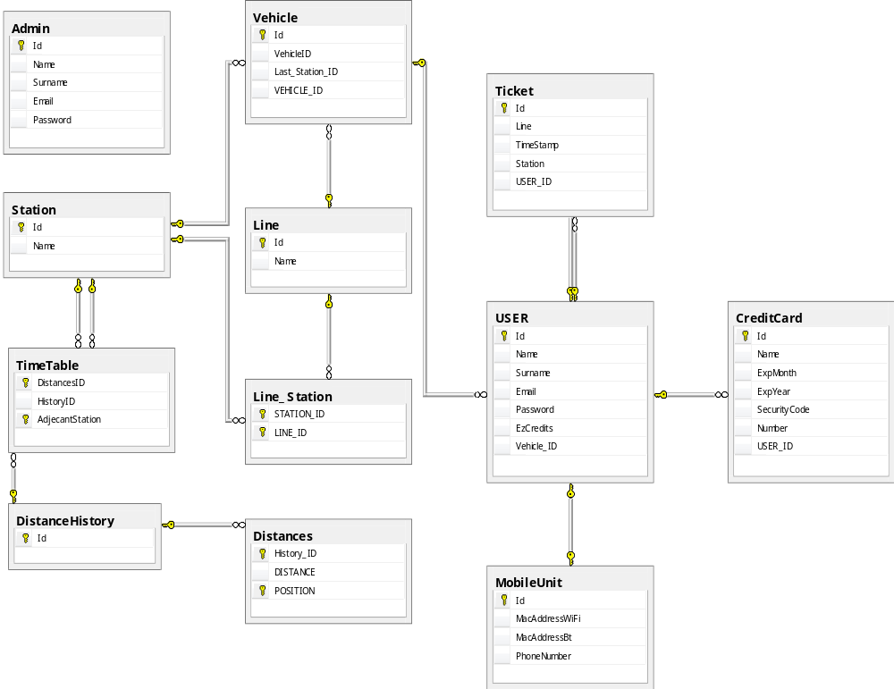

Figure 2

System Architecture
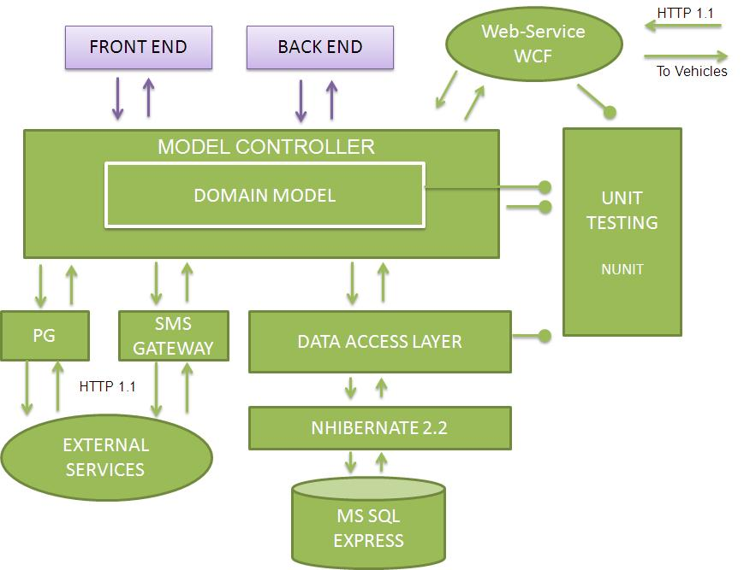

Figure 3
The figure above explains the architecture of the EzFare system. The Mainframe that is the think-tank of the system comprises of the MC and the DM. Other components of the system communicate with the MF to complete their task. As mentioned before you would notice the WA differentiated as Frontend and Backend. External Services such as notification to users and modes and means of paying are done through the Payment gateway and the SMS Gateway. Communication between the VU and MF is done using the HTTP protocols using REST services.

Approvals

Name | Title | Date  yyyy-mm-dd | Signature

